Chapter 4 notes

If we have a box/ object book calls it a memoryCell this is just like a place holder where we could go change object to string, Integer, Double, house …

Arraylist is where you put stuff in it. Its just an array that you can add stuff too.

Autoboxing and auto unboxing in java

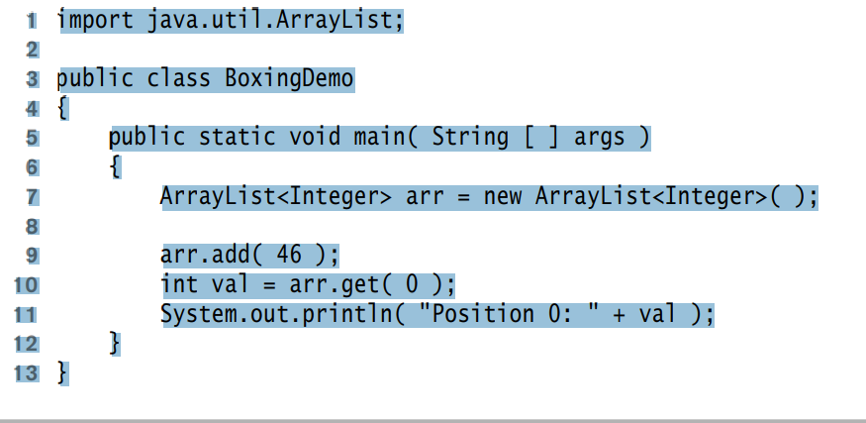

You can use generics by have a comparable and compare stuff to program generically

Real Generics:  
public class GenricBox<AnyType> {

Public AnyType read(){

}

Use AnyType as and be called

Will need the compareTo comparable to check if anytypes are the same

Generics don’t make code fast bust it makes your code more type safe at compile time.

Used to find bug earlier

privatives cannot be used in generics

Instanceof only works with the child

Static methods and fields cannot refer to the class type variables

Cannot create/construct a generic after it was made

Cant make a new array of anytype

Passing a function to method

Pass class that has a function you will call

Nested class hided class from other things

Put it in the parameter to get the other class

**Use a functor when you want to pass a method**

Dynamic dispatch